**Experiment no. 3**

**Write an Embedded C program to transfer elements from one location to another.**

**Algorithm :**

1. Initialize memory pointer to first element of destination memory block.
2. Initialize memory pointer to first element of source memory block.
3. Initialize counter to no. of elements in source memory block.
4. Go on transferring the element from source memory block to destination memory block.
5. Increment source memory pointer by 1. Increment destination memory pointer by 1 and decrement counter by 1.
6. If (counter ≠0), go to step 4.

**Flowchart :**

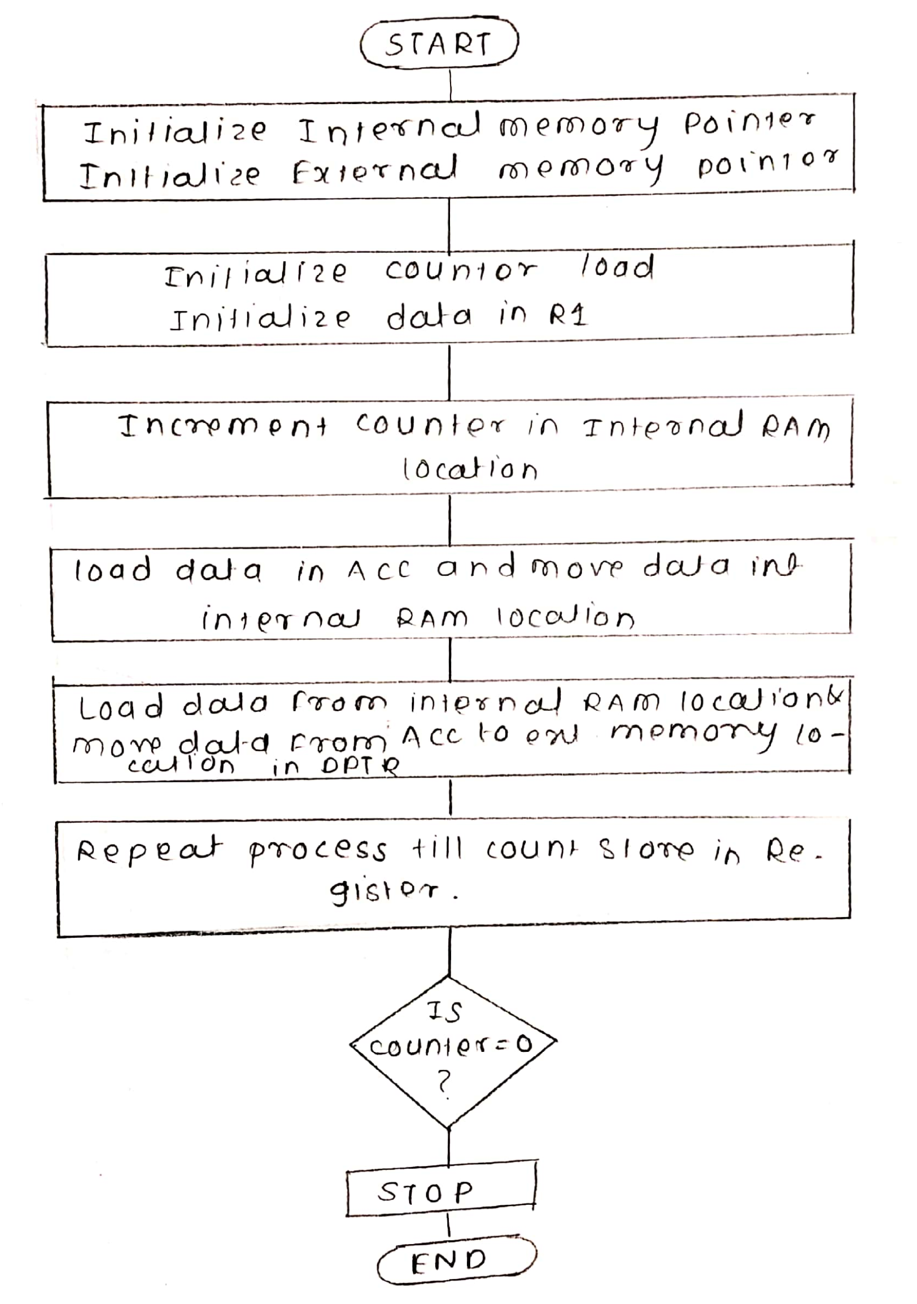

**/* Memory Transfer */**

#include <stdio.h>

#include <stdlib.h>

#include <pic18f4550.h>

/*

*

*/

void main(void) {

int temp,i;

int source1[] = {0x21,0x22,0x23,0x24,0x25}; // source mem block

int dest[] = {0x00,0x00,0x00,0x00,0x00}; // destination mem block

for(i=0; i<=4;i++){ // counter = 5

dest[i] = source1[i]; // source to destination

}

}

3.b. Memory Exchange

/*

* File: mem_xchg.c

* Author: Abhilasha

*/

#include <stdio.h>

#include <stdlib.h>

#include <pic18f4550.h>

void main(void) {

int temp,i;

int source1[] = {0x21,0x22,0x23,0x24,0x25};

int dest[] = {0x91,0x92,0x93,0x94,0x95};

for(i=0; i<=4;i++)

{

temp = source1[i];

source1[i] = dest[i];

dest[i] = temp;

}

}